**Hive Conceptual Demo**

**Processes/Operations that can be performed:**

* Company user can publish invoices on blockchain
* Invoices can have following states: Pending, OnSale, and Settled. Pending invoices are invoices that are waiting to receive payment and can potentially be soled but are not. OnSale invoices are those that company wants to sell in order to receive payment sooner. Settled invoices are those for which company has already received payments (from end customer or by selling it).
* Transfer Ownership
* For those invoices that company has put OnSale and agreed on terms, ownership will be changed to investor in the moment when smart contract receives HVN tokens in the amount that is equal to value of the invoice in EUR.
* Company can update invoice marking it paid. Only corporate user can update invoice status, security is insured by private key. System should also capture date of closing.
* In the case that invoice got closed and that in the same time was in the process to be sold to investor, the moment status is updated if it is still in the ownership of the company and takeover funds will be send back except the cost of the gas.

High Level view

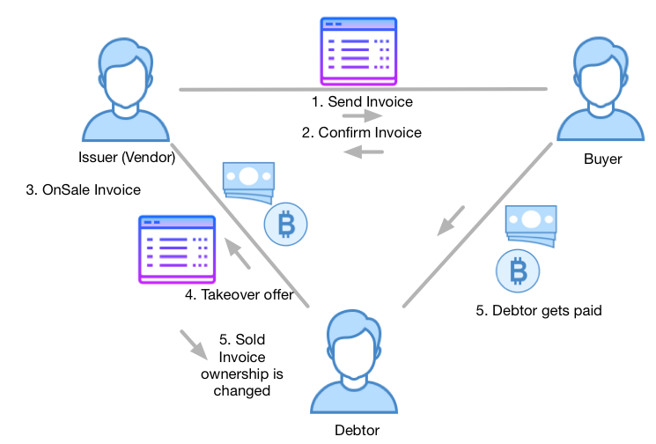

**Web UI operations**

* Publish invoice – returns address of the invoice
* Query invoice
* Security model – Owner (company that created the invoice)
* Sell invoice - transfer invoice to investor
* Close invoice manually – only owner can update invoice status manually
* List of all invoices grouped in Pending, OnSale and Settled
* Acknowledged invoices by Debtor. If invoice is disputed (rejected) user needs to provide explanation.

**Invoice Data**

* Issuance/Creation Date
* Due Date
* Invoice ID
* Issuer (Vendor)
  + Country
  + Name, Address 1, Address 2, City, Postal Code, VAT number, Tax number – Encoded and only accessible by private key

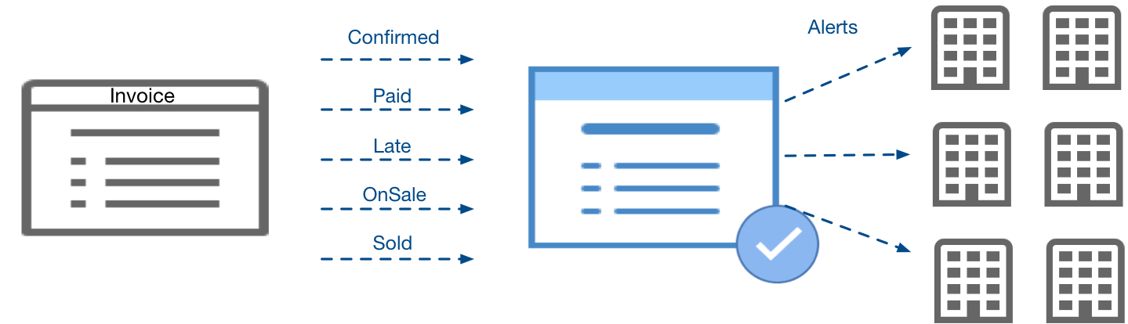

Following figure show Invoice lifecycle:

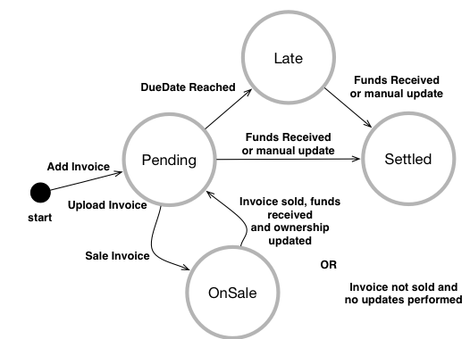

* Customer
  + Country
  + Name, Address 1, Address 2, City, Postal Code, VAT number, Tax number – Encoded and only accessible by private key
* Debtor
  + Country
  + Name, Address 1, Address 2, City, Postal Code, VAT number, Tax number – Encoded and only accessible by private key
* Amount
* Currency
* Takeover discount price – for PoC just simple approach that includes discounted takeover price and Expiry date of the discounted offer. After it reaches expiry date if invoice is not sold it will just move back to Pending invoices.

**Optional Operations**

Closing Invoice – there is few ways how invoice can be closed (settled)

1. Issuer of the invoice has privilege to access invoice and update manually status of the invoice to be closed.
2. Debtor sends to Issuer takeover request by sending agreed amount of fund in HVN tokens

**Considerations**

* Gas coverage
  + We should be covering gas price from Hive Gas Wallet. This is currently out of scope. Each time invoice ownership changes this wallet will be used. Funds for this are coming from cost of Ownership change that is charged to Debtor.
* Funding
  + If the funding sent to invoice is not enough to cover cost of the invoice plus transaction cost funds will be returned to the sender.
  + In the case that funds exceeds the amount difference will be sent back to the user.
  + In order to calculate Fiat we will need to integrate with a exchange or using for example CryptoCompare.com
* Security
  + How Debtor gets right to view details of the invoice? One of the options is that engages in communication with Issuer and then Issuer grants him right to see details. In this case recommendation is to have time limit on viewing right that is set by Issuer. Debtor is by default going to be able to see following fields: Amount, Takeover Amount, Invoice Due Date, Takeover Expiry Date, Company rating. Additional information that are available after viewing is granted are: Issuer Company Name, Invoice Number, Invoice Customer Name, etc. This feature is planned for V2